A Study on Ink Painting Blurring Effect for Making CG Ink Painting Animation

Dong JiaJia, Hou ZhengDong, YoungJick Jang, ChulYoung Choi

Department of Visual Contents
Graduate school, Dongseo University
Busan, South Korea
156857942@qq.com, freechoi21@gmail.com

Abstract

Ink-and-wash animations have mostly been produced in China. Recently, ink-and-wash animations are produced by using CG but most of them focus more on higher artistry than commercial approach. To popularize ink-and-wash animations requires approaches in three aspects. First, it is necessary to establish efficient ink-and-wash technique styles in production process; second, to make a commercial approach to Beijing opera in the perspective of scenarios and; third, to complete a fusion style that combine with the modern ink-and-wash painting of ink-and-wash style. This study attempts to find efficient ink-and-wash technique styles on production process, the first issue aforementioned.

Keywords-component; formatting; Ink-Painting, Ink-Wash Animation, Blurring Effect

I. Introduction

Originating in the late Tang Dynasty, ink-and-wash paintings have been inherited and developed over a long period of time. Ink-and-wash techniques include Oriental painting’s unique painting patterns and its artistry was applied to the first ink-and-wash animation To Find Tadpole’s Mom (小蝌蚪找妈妈) released in 1960 and it was successfully put into animation format. Based on the public’s explosive interest, ink-and-wash animations have continuously been created and today’s development of CG technology enables production of 3D ink-and-wash animations. Thus, Ode to Summer, the first 3D ink-and-wash animation produced in 2003, realizes ink-and-wash techniques with fantastic images using 3D software Autodesk Maya.

A. Cell Ink-Painting Animation

The sense of form found in Ink-Painting presents an image which stands out from the clean and refined aesthetic of contemporary design[1]. Ink-painting expresses the form and depth of objects through the variation of ink concentration; ink and paper presents a harmony of black and white with an emphasis on the beauty of empty space. It is an art of serenity. Such Northeast Asian aesthetic has found visual manifestation in a number of animation films.
On the production process of <The Cowboy's Flute, 1964> by Te Wei of Shanghai Art Film Production (Fig. 1), Sa Hyowook (2011) observed that the colouring part must be done in layers; even with the same head of a water buffalo, they used 4-5 different colours, pinkish grey and dark grey for large areas and greenish ink colour for the horn and wrinkles around the eye. Each colour is applied on the layers of transparent cellophane[2]. Kwon Sehyuk (2011) also commented that the animation film coveys the analogue feel of ink painting[3]. This points to how the expression of tranquility-in-dynamics and the aesthetics of emptiness, all characteristic features of ink painting, have been applied to 2D animation to find an application in moving figures. In the early days of animation in the 1960s, this was a labour-intensive process demanding much time and manpower.

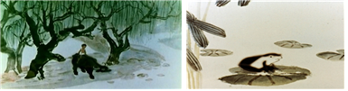

Fig. 1 Left) <The Cowboy's Flute, 1964>, Right) <A stadpole Looking for Mom>

The right side of the Figure 1) is To Find Tadpole’s Mom, the very first ink-and-wash cell animation directed by Te Wei (特偉) in 1960 based on ink-and-wash painting by Qi Baishi (齊白石). On the ink-and-wash painting used on the animation, Kim Yoona (2010) stated that ‘Ink-and-wash painting has been a pictorial medium that represents not only China but the entire East and gives Asians affinity and westerners novelty and a unique world view of the East’[4]. Ink-and-wash animation in this early stage has an advantage that it can express ink-and-wash technique as it is but it requires labor-intensive production processes that demand too much time and human labor. In an ink-and-wash animation, shooting is done by moving a character picture that each part cut out is connected. To keep feelings of ink-and-wash painting, bringing cameras into different sets of focus for multiple shooting is particularly difficult and cumbersome, which needs much manpower and time as well[5].

B. CG Ink-Wash Animation

Figure 2 <Ode to Summer>, the first 3D Ink-Painting Animation that appeared in 2003, was produced by director Shee, using 3D software Autodesk Maya. Lee Young-heon (2007) said that the entire process was processed in monochromatic tone and the smoothness of the end point of the surface was smoothly reproduced with computer graphics[6]. Autodesk Maya 's shading setting values were used to express the unique jade of the ink painting technique and the intensity of the line. Through Non-realistic rendering, the realistic depiction and the perspective were expressed. In this way, China's Ink-Painting Animation started from the cell technique of 2D animation, and was re-created in 2003 using 3D animation. Recently, Using VFX effects of 3D animation, we are creating more fantastic images by using the latest technology in the artistry of traditional ink painting.

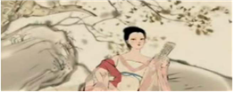

Fig. 2 <Ode to Summer>

2D and 3D animations produced on the basis of ink-and-wash painting techniques and traditional artistry have their own sensuous expressiveness. Producing media, expression techniques and features of ink-and-wash painting, 2D cell animation and 3D ink-and-wash animation are as shown in the Table 1 below.

II. ink-Painting Style using CG
The most important factor in ink-painting style animation is the ink line on the outline and the run of ink in inner areas. In the past, ink lines were drawn by hand and then scanned onto the computer to produce outlines in order to recreate that analogue feel. In recent years, however, the Hong Kong-made ink painting tool Expresii has enabled ink line drawing and the expression of ink run so that ink-painting style animation can be produce digitally.
In the process, tools such as Expresii, Photoshop, Autodesk Maya and After Effect are used.

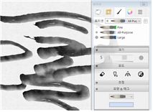

Fig. 3 Ink line drawing with Expresii

A. Creating Ink-painting Animation Characters
TABLE I
KINDS AND DIVISION OF INK-WASH ANIMATION

/ | Ink-Painting | 2D Cell Animation | 3D Ink-Wash Animation
Division | Ink-Painting | Cell Animation | 3D Graphic Animation
Production Medium | Wood-written ink  ( 紙筆硯墨) | Cellophane, Wood-written ink  ( 紙筆硯墨) | Shading and non-realistic rendering techniques in Maya
Expression Techniques and Methods | technique of the Jung Joong Dong, The beauty of space, Near distance, Expression of distant view | technique of the Jung Joong Dong , The beauty of space, Near distance, Expression of distant view | Implementing more useful dynamic images, Expression technique of the Jung Joong Dong
Implementation Characteristics | Center of artistry | Labor intensive  Traditional artistic, | Technology-centric,  Traditional artistic

Characters in ink-painting animation show the variation in ink outline as well as run effect even in the same colour. Thus modelling data for CG character should be simple and articulate so as to facilitate the expression of such textures. The figure is a character in a fusion Beijing opera animation, produced with CG to capture the concept image.

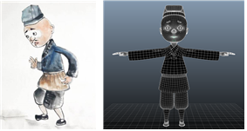

Fig. 4 Ink-Wash character concept image and modeling data

B. Modelling and Texture

Before applying ink-painting style, modelling data’s UV needs to be unfolded so that ink-painting texture can be put on to modelling data. This is the same as any other animation-making process.

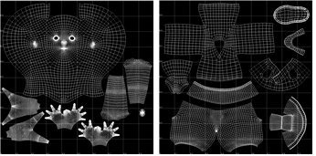

Fig. 5 cloth UV and body UV

Afterwards, Expresii and Photoshop are used to creature ink-painting texture and colours in accordance with UV.
TABLE 2
Composing process with the render layer
Classification | Image | Text
Lander layer | 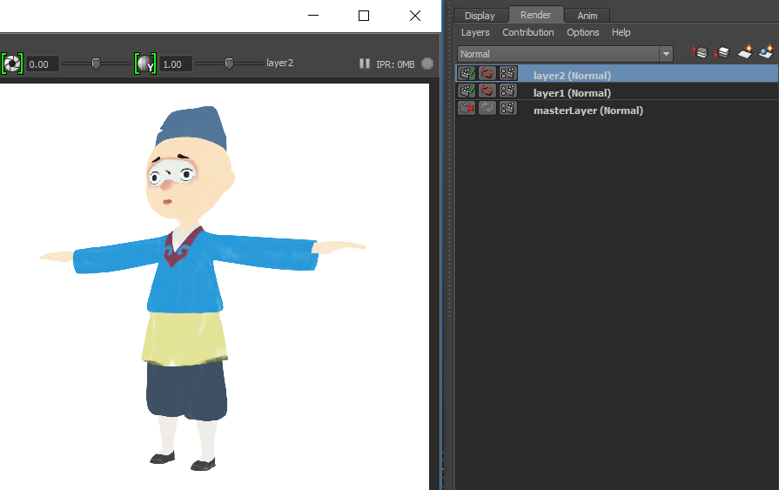 | RGB image extraction for synthesis
Lander layer | 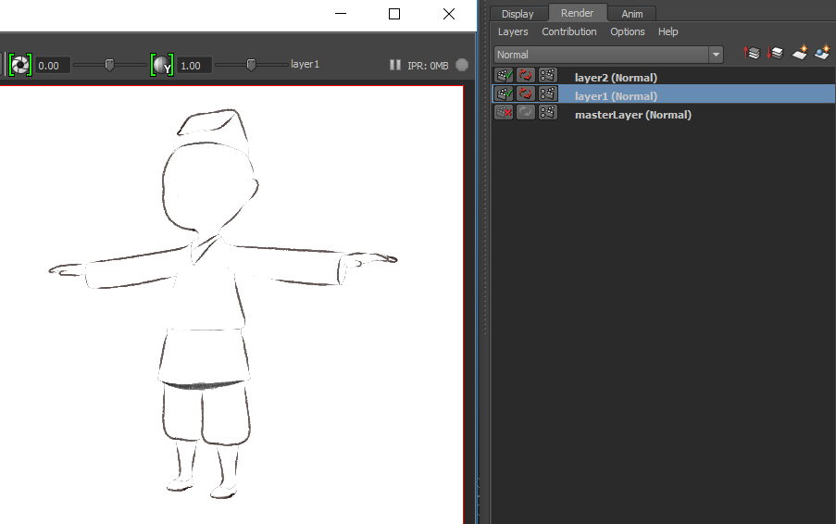 | Extract images by separating the tokens of Toon Shader
Synthesis | 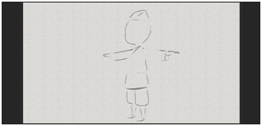 | Applied Ink line layer
Synthesis | 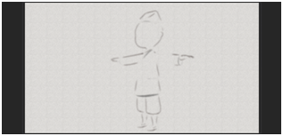 | Apply a filter to smooth the boundaries between image and background
Synthesis | 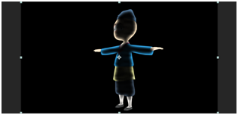 | Apply a filter inside the appearance line to correct the diffuse outline of the image below
Synthesis | 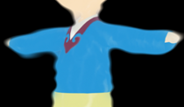 | Apply a filter to spread the outline outward
Synthesis |  | Image of paper texture for background application

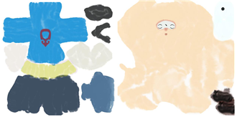

Fig. 6 cloth texture body texture

C. Shader production
To complete shader, import texture from Maya’s hyper shader window and connect to lamber surfacer. Considering features of ink-and-wash painting, make shader by using lamber surface to minimize lighting’s influence and highlight flat images. Apply Maya’s Toon shader and to express light and shade of ink lines, complete the changes of thickness of ink lines by adjusting shader’s attribute. Save it as preset to apply shader to other characters.

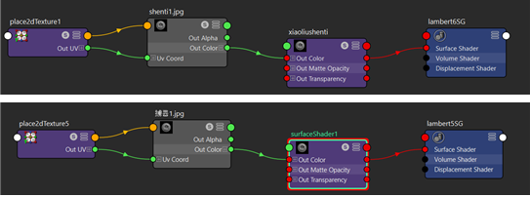

Fig. 7 top) body shader, botton) cloth shader

Apply the Toon shader of Autodesk Maya and change the thickness of the shader to adjust the attribute of the shader to express the shade of the shader. Save it as a preset to apply the Shader to other characters.

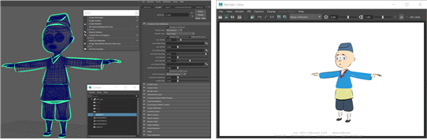
Fig. 8 make a toon shader and render image
D. Ink-Run Brush Effect
A characteristic feature of ink-painting is that, like water painting, ink run happens when a brush touch the paper. While the inside and outline of a character is in ink-painting style, for this character to blend in with the background, the colour of the character needs to run into the exterior. As such effect cannot be produced by CG modelling, this must be done in the process of composition; for composition, outline and inner colour must be rendered separately. The table 2, presents how separate rendering creates ink-run effect in the composite stage.

The final result is shown in the following figure.

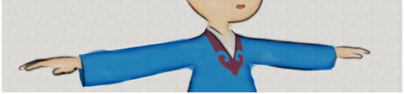

Fig. 9 Final Ink-Wash image with blurring effect

III. Conclusion

Headed by Disney/Pixar, animations using computer graphics have been continuously developed recently and they are sometimes described as realistically as films. As CG facilitates not only realistic descriptions but also various styles, it would be the only option to diversify producing methods and restore traditional cultures in a modern way so that Asian countries with rich history get in on this global race. Producing processes of ink-and-wash animation on this study consist of shortening the rendering time as much as possible and facilitating light work without any additional plug-ins while they can be implemented on old versions’ software as well. Henceforward the study seeks to examine possibilities of commercial popularization as a process of reinterpreting traditions using creative ideas.

References

[1] F. Qiang-Qiang, K. Maeng-Ho, A study on the expression of indian ink in television commercial, The Korea Contents Society, 229-234, 2009.
- S. Hyo Wook, Relation between Science and Art, Shanghai University, 2011.
- K.Se-Hyuk, L. Sang-Won, Visual Effect an Alysis that Appear in Formative Feature of India Ink Animation, The Animation Society of Korea, 50-51, 2011.
- K. Yoon Ah, A Study on the Chinese Water-ink Animation in the Use of Original Ink Paintings - Focusing on A stadpole Looking for Mom, The Korea Culture Contents, 55-92, 2010.
- H. Eui Woong, Ink-wash tadpoles admired by Picasso, Dol do rae, 2013.
- L. Young Hun, A Study on the NPR(Non-Photorealistic Rendering) Usrd in 3D Animation, The Korea Contents Society, 94-101, 2007.

